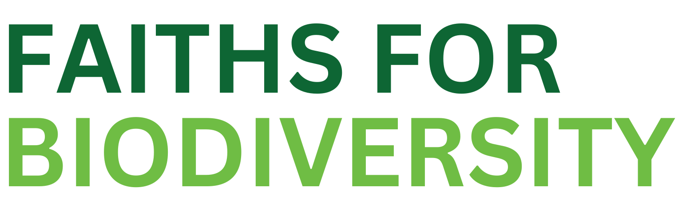
Case Study Submission Form
Faith Implementation of the Kunming-Montreal Global Biodiversity Framework

GUIDANCE NOTES:
For more details about the GBF Faith Implementation Report, please visit: www.biodiversity.faith/gbf-report
On completion of this form, please email it to: report@biodiversity.faith
Each organization is invited to submit up to 2 different case studies. Please use separate forms when doing so.
Forms must be submitted by April 26th, 2024
Cases can be submitted in English, French or Spanish.

NAME OF SUBMITTER:

NAME OF ORGANIZATION(S):

PROJECT NAME:

PROJECT LOCATIONS:

PROJECT START DATE:

KMGBF TARGETS THE PROJECT IS IMPLEMENTING:
Select all that apply - for a description of the targets, visit https://www.cbd.int/gbf/targets

☐ Section C para 7 (c) on A whole of society approach
☐ Section C para 7 (o) on Formal and informal education
☐ Section K para 22 on Communication, education, awareness and uptake
☐ Target 1: Plan and Manage all Areas To Reduce Biodiversity Loss
☐ Target 2: Restore 30% of all Degraded Ecosystems
☐ Target 3: Conserve 30% of Land, Waters and Seas
☐ Target 7: Reduce Pollution to Levels That Are Not Harmful to Biodiversity
☐ Target 10: Enhance Biodiversity and Sustainability in Agriculture, Aquaculture, Fisheries, and Forestry
☐ Target 11: Restore, Maintain and Enhance Nature’s Contributions to People
☐ Target 12: Enhance Green Spaces and Urban Planning for Human Well-Being and Biodiversity
☐ Target 16: Enable Sustainable Consumption Choices To Reduce Waste and Overconsumption
☐ Target 19: Mobilize $200 Billion per Year for Biodiversity From all Sources, Including $30 Billion Through International Finance
☐ Target 22: Ensure Participation in Decision-Making and Access to Justice and Information Related to Biodiversity for all
☐ Target 23: Ensure Gender Equality and a Gender-Responsive Approach for Biodiversity Action

PROJECT DESCRIPTION:
300 words maximum

ARE YOU ALSO SUBMITTING PROJECT RESOURCES, IE. FLYERS, VIDEOS, PHOTOS

☐ Yes
☐ No

